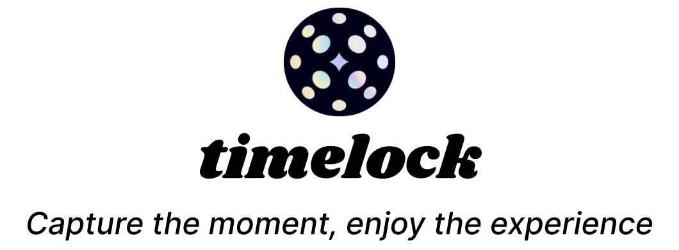

Final Report
CS 147 Fall 2024
Design for Movement
Isabelle Levent, Sophia Latessa, Regina Sevilla, Anna Van Buren

Table of Contents
Project Name & Value Proposition 3
Team Members & Roles 3
Problem and Solution Overview 4
Needfinding 4
Interviews 4
Recruitment methodology 5
Interview & Synthesis Methodology 5
Key Insights 5
Empathy Map Highlights 6
POVs & Experience Prototypes 10
Julia’s POV 10
HMW Statements from Julia’s POV 10
Karrie’s POV 10
HMW Statements from Karrie’s POV 10
Nate’s POV 10
HMW Statements from Nate’s POV 11
Top 3 HMW Statements from Across the 3 POVs: 12
Solutions 13
Top 3 Solutions 13
Experience Prototypes 13
Design Evolution 17
Final Solution 17
Tasks 17
Design Evolution 19
Initial Sketches 19
Lo-Fi Prototype and Evaluation 20
Medium-Fi Prototype and Heuristic Evaluation 25
Values 32
Value Tensions 33
Tools Used 34
Hard-Coded Data and Limitations 34
Wizard of Oz Techniques 34
Reflection & Next Steps 34
Key Learnings About the Design Thinking Process 34
Key Learnings About Studio Theme 35
Key Learnings About timelock 35
Next Steps 36

Project Name & Value Proposition
Timelock | Capture the moment; enjoy the experience

Team Members & Roles

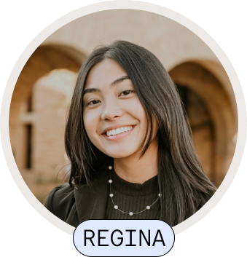 | Regina Sevilla  As our technical co-lead, Regina built our website, led experience prototype testing, starred in our concept video, and co-created the high fidelity prototype. She served as a User Researcher, Mobile Developer, and Web Developer for timelock.

Isabelle Levent  As our lead organizer and product wizard, Isabelle helped design and ideate the final product solution, directed our concept video, and organized many of the presentations and deadlines for the team. She served as a User Researcher, Product Manager, UX Designer, and Pitch presenter for timelock. | 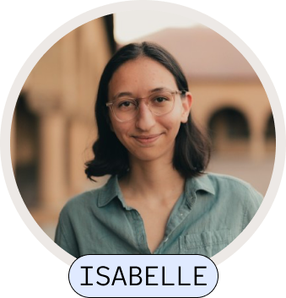

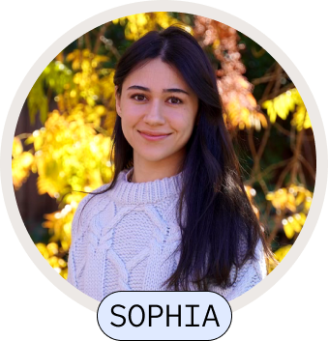 | Sophia Latessa  As the figma and user experience expert of the team, Sophia led the concept sketches, designed the low and medium fidelity prototype, and created the experience prototypes. She served as an User Researcher, UX Designer, and poster designer for timelock.

Anna Van Buren  As our technical co-lead, Anna co-created the high fidelity prototype, starred in our concept video, and spearheaded ethical considerations for the product. She served as a User Researcher and Mobile Developer for timelock. | 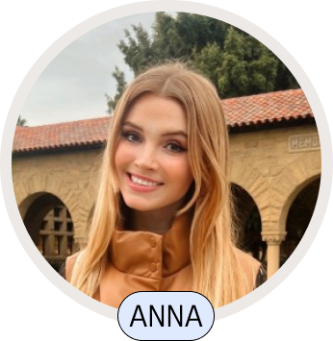

Problem and Solution Overview
People want to capture and share memories of important social events while staying present in the moment. Timelock is a social app that allows friends to collectively document events. In Timelock, friends join an event, contribute a few memories throughout, and leave with a multi-media memento of the event.

Needfinding

Interviews
Our design process started with six interviews to narrow in on our problem space of creating memorable experiences and artifacts from important social events. Our initial goal was to find participants who exemplified different types of event attendance (low event attendance vs high event attendance), media capturing at events (“photo friend” vs. the friend who doesn’t take any photos), and representatives from both event attendees and organizers. Initially, we spoke to…

- Mary: Stanford student in her early 20s who attends ~6 large events/parties per month
- Clara: Santa Clara student in her early 20s, the designated "photo friend" at events
- Julia: Musician and events business owner in her mid-30s (extreme user)

After interviewing our first batch of participants, we decided to focus on extreme users who either organize events or are passionate event goers. We relied on introductions from friends and family to contacts in the music festival industry. Given our network, we were able to interview…

- Nate: Frequent festival and concert-goer in his mid-20s
- Karrie: Music festival worker and frequent attendee in her mid-30s
- John: Festival company co-founder in his mid-30s

Key questions going into our interview included…
- Building rapport, e.g., when was the last time you hosted an event? Do you host a lot?
- Evoking stories, e.g., What are the things you remember most about [X event]? Do you do anything after an event to commemorate it?
- Digging deeper, e.g., how do you typically share photos/memories from an event?

Recruitment methodology
In order to find event attendees, we visited Town & Country and screened potential interviewees with questions about event attendance. Once we narrowed our interest to talking to event coordinators, specifically music festival organizers, we relied on introductions from friends and family to contacts in the industry. We did not compensate our interviewees.

Interview & Synthesis Methodology
Interviews were conducted in person with two team members present: one interviewer and one notetaker. We used Otter.ai to record and transcribe the interview. After each interview, we created empathy maps to better understand our users and identified contradictions, surprises, and tensions that arose from our interviews.

Key Insights
From event attendees, we learned that event goers need creative ways to remember favorite events that go beyond photo albums. For example, Clara prints photographs from memorable events and gives them to friends as gifts. Young event attendees want photo sharing to be as seamless and easy as possible, but will invest time and energy in creating physical and digital artifacts. We learned that there are two types of event attendees when it comes to media creation: the “photo friend” and the friend who wants the photos, but doesn’t want to take them. Nathan, a frequent festival and concert attendee in his mid-20s, put it best:

“I want to be present at festivals and concerts so I don’t use my phone, but I like that my friends take photos and share them with me”

From event organizers, we learned that they are also looking for unique ways to compile memories beyond standard digital artifacts like photo albums. The events industry is relationship-driven; mementos help business owners stand out and retain clients.

Empathy Map Highlights
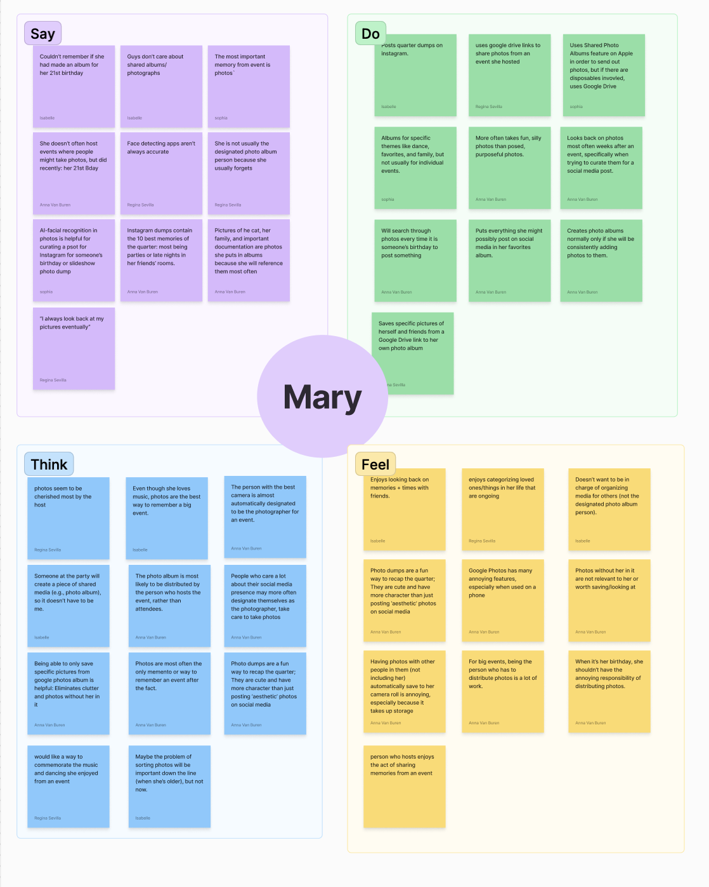
Figure 1: Empathy Map for Mary.

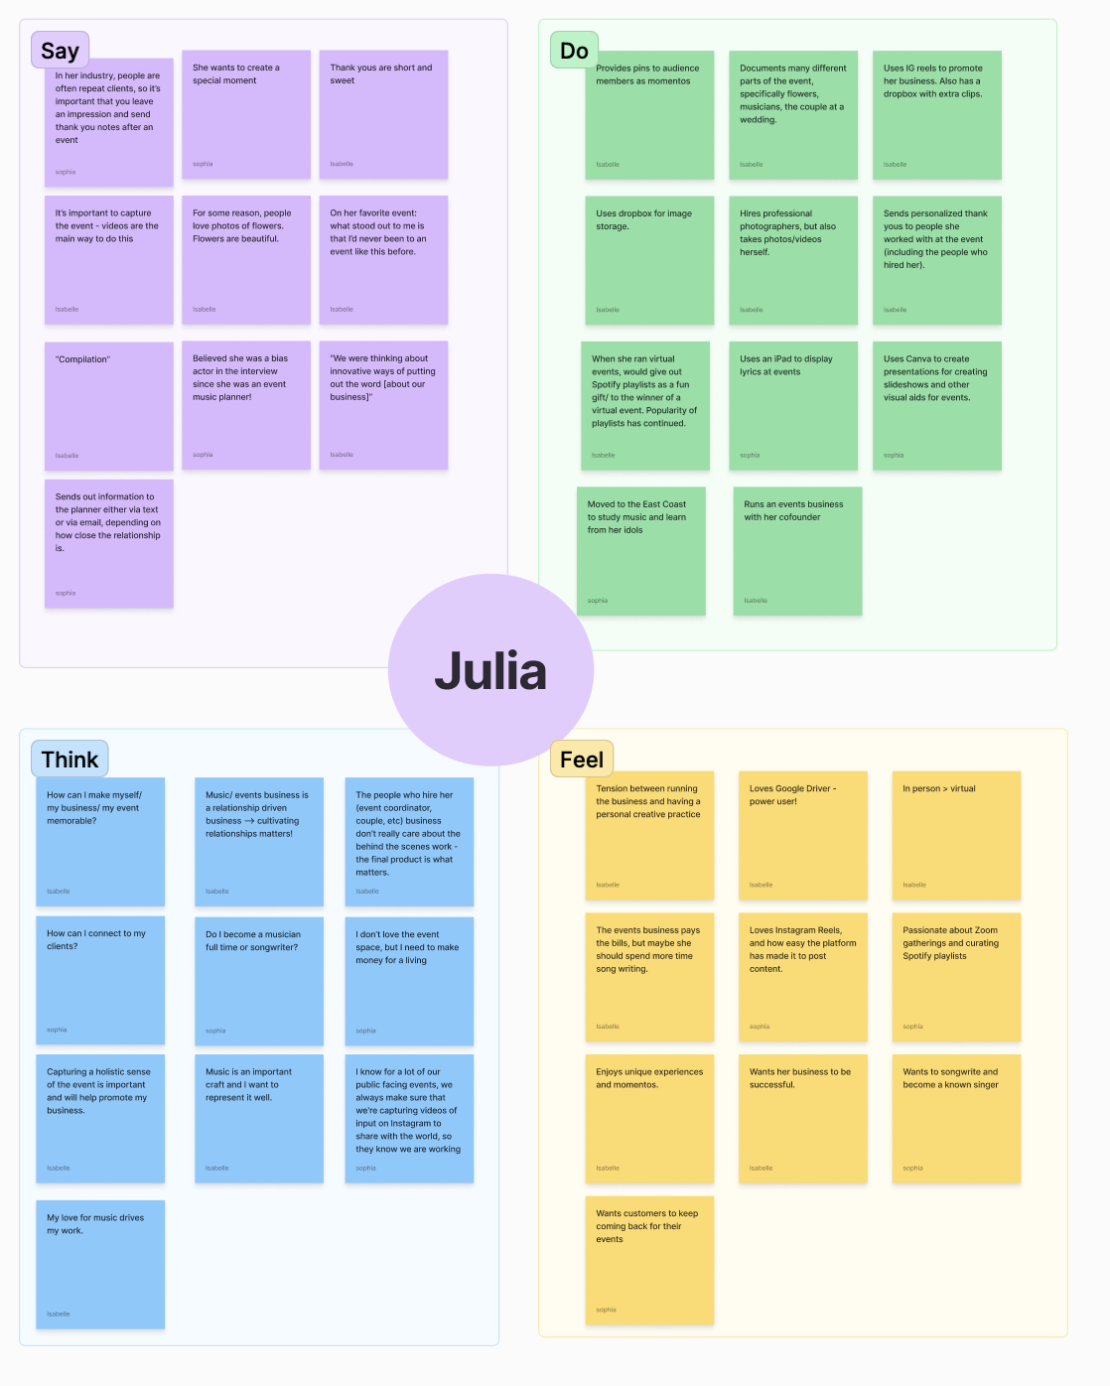Figure 2: Empathy Map for Julia.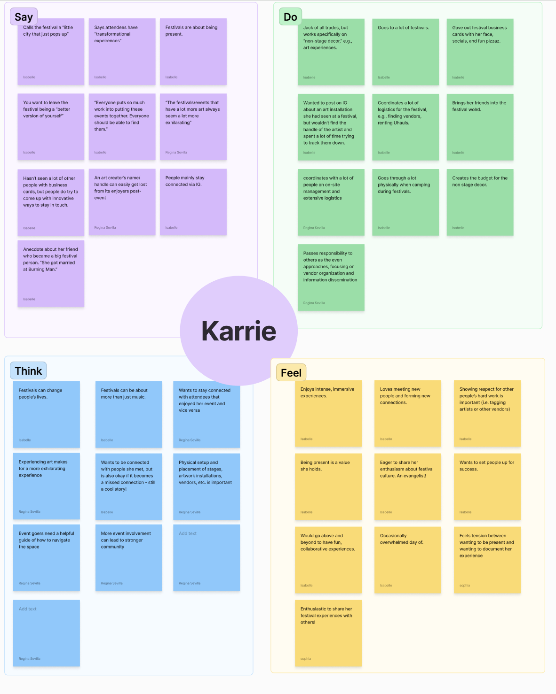
Figure 3: Empathy Map for Karrie.

POVs & Experience Prototypes
After conducting six interviews, we continued our design discovery process by generating POV statements for the most interesting three of our six interviewees: Julia, Karrie, and Nate. These three participants spanned both passionate event attendees and event organizers.

Julia’s POV
- We met a Bay area musician and events small business owner who creates post-event tokens.
- We were surprised that she sends thank-you notes to everyone she works with.
- We wonder if this means she believes that spending time on creative mementos is valuable because that's how she retains clients best.
- It would be game-changing to better foster relationships with her clients.

HMW Statements from Julia’s POV
- HMW help event organizers leave a unique, memorable impression on attendees?
- HMW might we create better personalization for each client?
- HMW might we make photo distribution for event organizers more streamlined?

Karrie’s POV
- We met a music festival organizer and enthusiast who coordinates logistics for festivals she attends.
- We were surprised to realize that she finds it stressful balancing wanting to be present at the festival and wanting to memorialize the experience.
- We wonder if this means she finds it stressful/distracting to capture event details and memories in the moment.
- It would be game-changing to provide her a seamless way to enjoy the moment and focus less on capturing event details and memories.

HMW Statements from Karrie’s POV
- HMW make documenting the festival simple and exciting?
- HMW create an experience that is as easy as one click to memorialize event details?
- HMW connect people who want to document during events to those that want to be present only?

Nate’s POV
- We met a frequent festival and concert-goer in his mid-20s.
- We were surprised to realize that while he values the stage productions and overall experience, he finds that capturing the right "vibe" is crucial but can easily go wrong.
- We wonder if this means he believes that the social atmosphere and community experience are more valuable than just collecting media.
- It would be game-changing to help him preserve the feeling and energy of an event without diminishing the live experience.

HMW Statements from Nate’s POV
- HMW capture the atmosphere of an event beyond just photos and videos?
- HMW preserve the social connections made at events?
- HMW balance preserving memories with staying present in the moment?
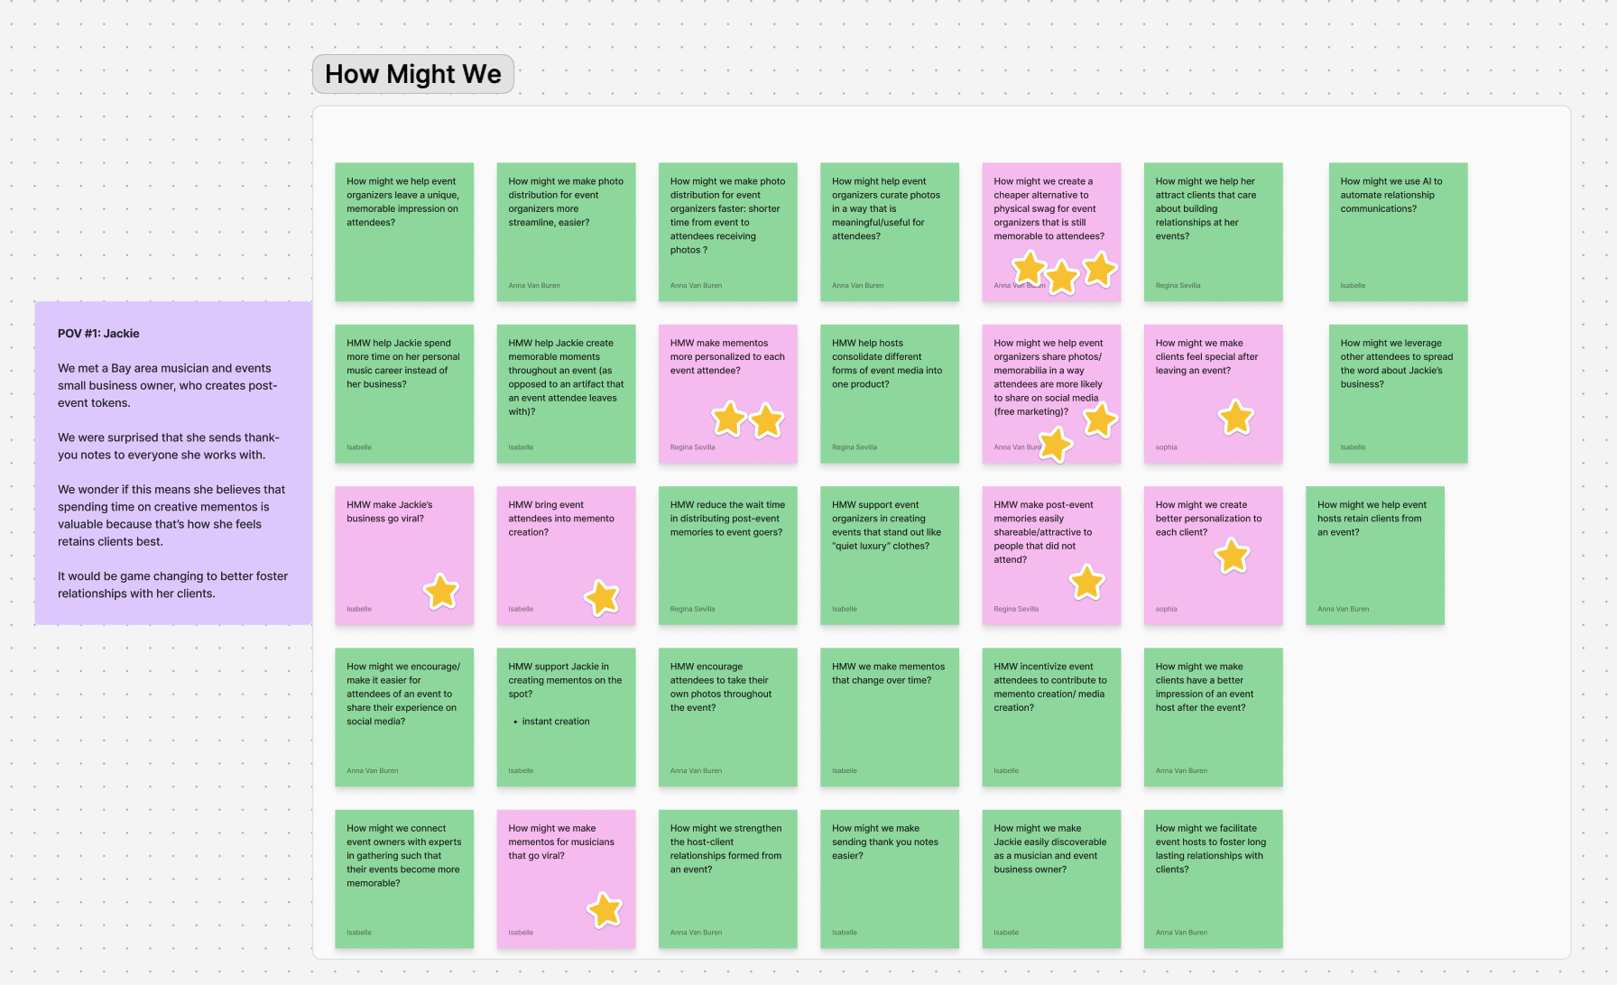
Figure 4: FigJam exploration HMW’s for Julia.
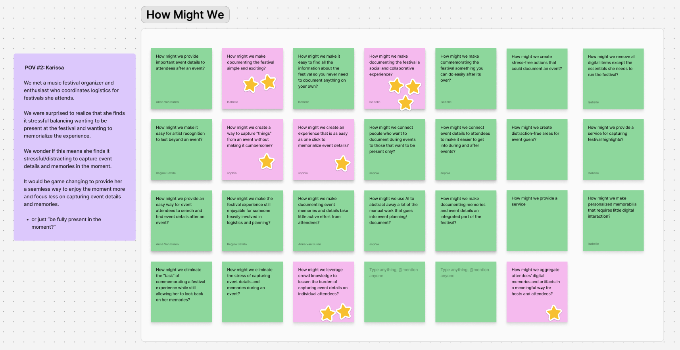
Figure 5: FigJam exploration HMW’s for Karrie.

Top 3 HMW Statements from Across the 3 POVs:
- HMW we create a cheaper alternative to physical swag for event organizers that is still memorable to attendees?
- HMW make documenting events a social and collaborative experience?
- HMW create better personalization to each client so they leave an event feeling special?

Solutions
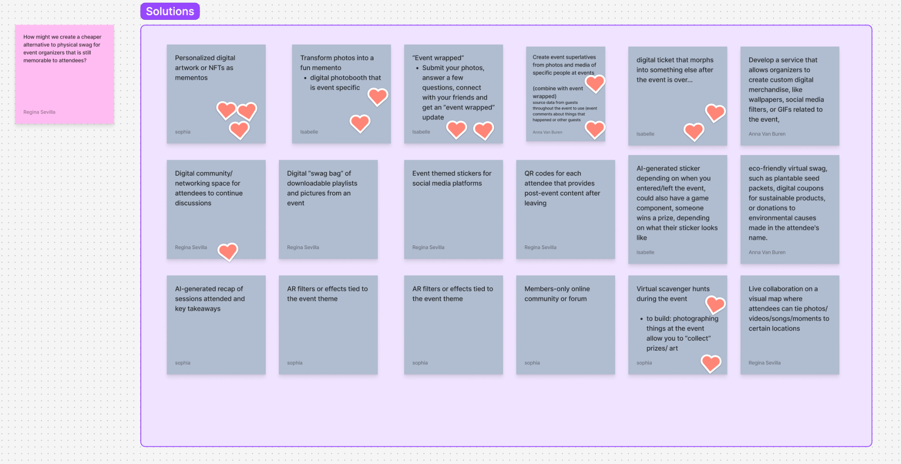
Figure 6: Empathy Map for Julia.Figjam brainstorm solutions for one of our HMWs.

Top 3 Solutions
- Event Wrapped: Submit photos, answer a few questions, and get an "event wrapped" (in the style of Spotify wrapped) memento of your event.
- Digital Name Tags: Event attendees create digital name tags that are conversation starters and can post-event become mementos.
- NFTs/Digital Art: Event attendees receive a personalized digital artwork based on their event experience that can be a memento.

Experience Prototypes
We took our three solutions and created experience prototypes to test core assumptions.

#1: Event Wrapped
Assumption Tested: Attendees will actively participate by submitting photos and answering questions about their event experiences.

In order to test this prototype, we recruited a recent event attendee willing to share photos from a recent event. We gathered comprehensive event details such as time, location, and key moments, and curated a narrative that captured the essence of the event. Using tools like Figma and Canva, along with the provided photos and videos, we designed a custom, interactive experience that mirrored the chronological flow of the event. The final result was a dynamic, multi-screen presentation that highlighted the most memorable aspects, creating a personalized retrospective of the event.
The aspects of the prototype that worked were our ability to generate a cohesive visual theme matching the event, chronological photo arrangement reflecting the chronology of the event, and to pull from a group photo album, so that the memento reflected the group experience.
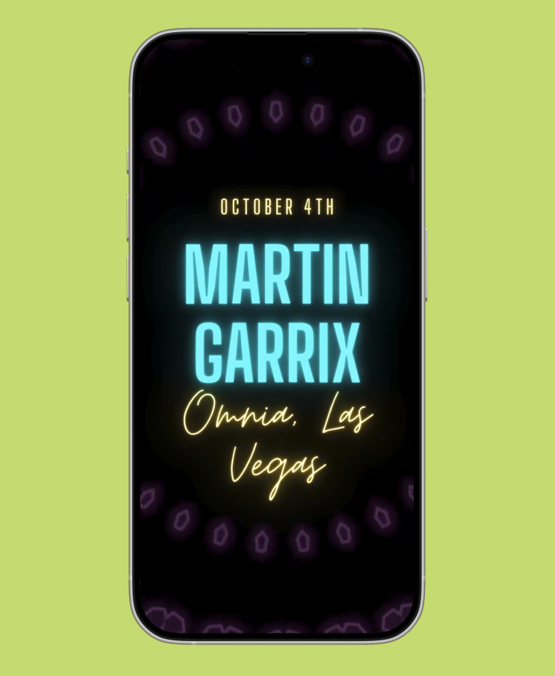
Figure 7: Events Wrapped for Martin Garrix Concert

The prototype, however, could be improved aesthetically and lacked sufficient personalization (e.g., the participant noted that for group events she wouldn’t have wanted to see photos of everyone from the group).

Our key learnings:
- Users prefer personalized content that reflects the important parts of their event experiences, e.g., their specific friends.
- Design quality for a memento significantly impacts the perceived value. The roughness of the experience prototype made it seem less valuable to the participant.

#2 Digital Name Tags
Assumption Tested: Name tags are valuable to have at events because they prompt people to converse.
In order to test this prototype, we identified a 26-year-old software engineer at a crypto company who frequently attends conferences. This participant provided valuable insights as they represented a different type of event-goer - someone attending conferences primarily for professional development and networking. We had them walk through Vercel's onboarding process for their NextConf event, which concludes with the creation of a virtual badge.
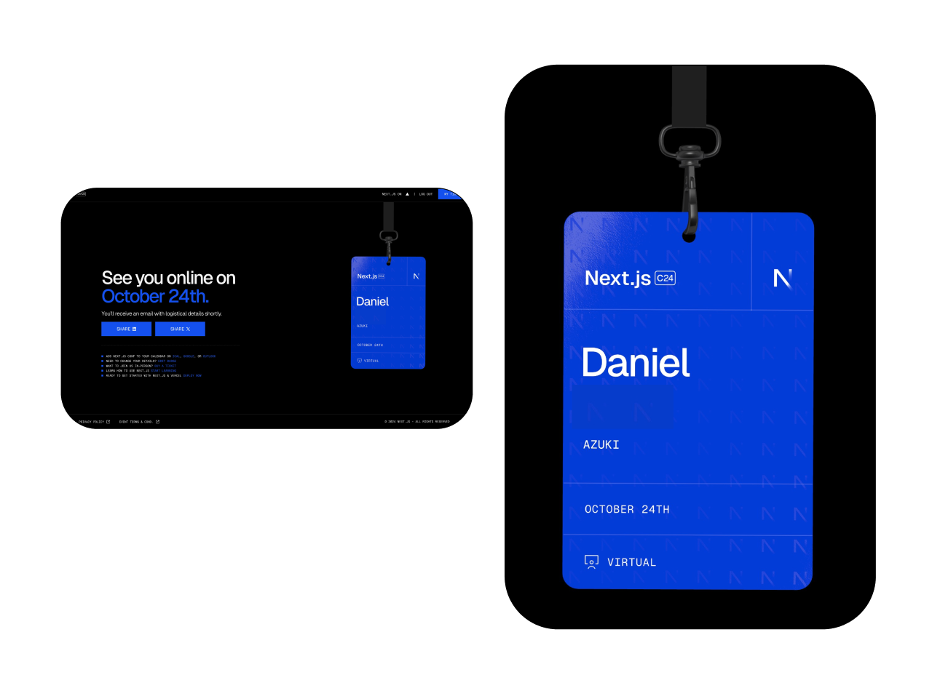
Figure 7: Participant’s final name tag after experience prototype test
The aspects of the prototype that worked well were the seamless digital name tag creation workflow and the participant's natural inclination to share their badge on social media platforms after creation.
The prototype also revealed important insights about the user experience. Most notably, the participant was particularly drawn to the animations in the virtual badge experience, emphasizing that the "feeling" of creating a badge should be magical. Additionally, we found that the digital format naturally encouraged pre-event sharing and generated FOMO (fear of missing out) among their network.
Our key learnings:
- Interactive elements and animations significantly enhance user engagement with the badge creation process
- Social sharing features are essential to the experience, not just optional
- The digital format extends the impact of the name tag beyond the event itself, creating value before, during, and after

#3 Personalized Digital Art
Assumption Tested: Attendees are excited about digital event tokens that are not related to their own media/photographs.

In order to test this prototype, we recruited a participant with a recent memorable event experience and gathered details about the event. We then generated a personalized “aura” visualization of the event using Midjourney and Canva.
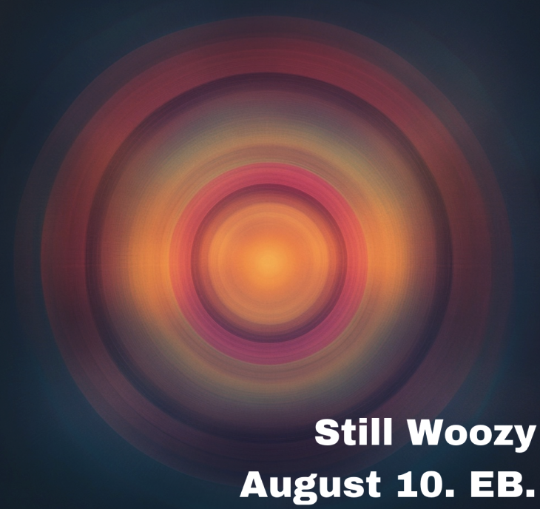
Figure 9: Final version of personalized digital art

The prototype generated genuine excitement and the participant spent time looking at it; she was also curious about the creation process. Although she expressed interest in the token, she didn’t seem eager to share it although she was interested in what her friend’s tokens would have looked like.

Our key learnings:
- Similar to our learning in the event wrapped prototype, we learned that the design of the post-event memento is critical. Our design happened to emulate the mood of the concert which is why our participant liked the token.
- Describing the concert ended up being part of the experience of creating the token. Contributing to a token can make a user nostalgic and more bought into the process.
- Importantly, the event already has to be meaningful to the participant for the token to be meaningful.

Design Evolution

Final Solution
From interviews, we heard that passionate event-goers feel a tension between documenting their experiences and staying present. At the same time, we learned that event hosts, including professionals, find value in event mementos and put in a lot of effort to create them. After our experience prototypes, we realized we needed a) to narrow down on one of the two types of users we interviewed (professional hosts vs attendees) and b) to design an entire product experience, instead of specific features, that focused on aggregating memories and sharing them in an aesthetically pleasing way.

Timelock is an app for collaboratively collecting multimedia during important social events, while staying present. It provides a novel way to create event mementos that distributes the responsibility for documentation and encourages users to stay present at their events.

In the app, users contribute various forms of content (photos, videos, voice recordings, songs, locations, messages) within a limited timeframe, so that users are encouraged to focus on the experience instead of capturing it. All contributions are then compiled into a single, shareable memento, capturing the essence of their experiences.

Tasks
Task #1, Simple: A user contributes a piece of media to a timelock event.
Contributing a piece of media is a core functionality of the app and the primary way users add to the final memento. All users will contribute a piece of media at least once throughout the event. This task requires users to select a media type, capture a piece of media, and submit.
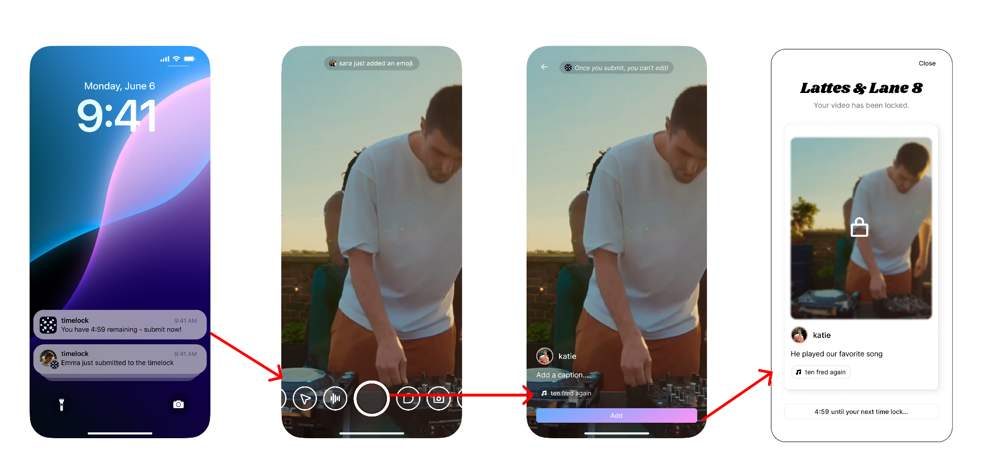
Figure 10: A user can contribute to a timelock by clicking the pop-up notification at a certain time, and capturing a piece of media (e.g. video, photo, voice memo, etc.). In this case, the user has recorded a video. Then, the user has the option of adding a comment, and finally submitting.

Task #2, Moderate: A user starts a timelock event.
Each timelock event has a host/admin who initiates the event and invites people to contribute. This task is necessary to set up the timelock experience for all users within an event, but only requires one person to complete it. A host is able to name and describe the event, select a timeframe and media types, adjust privacy settings, and invite friends.
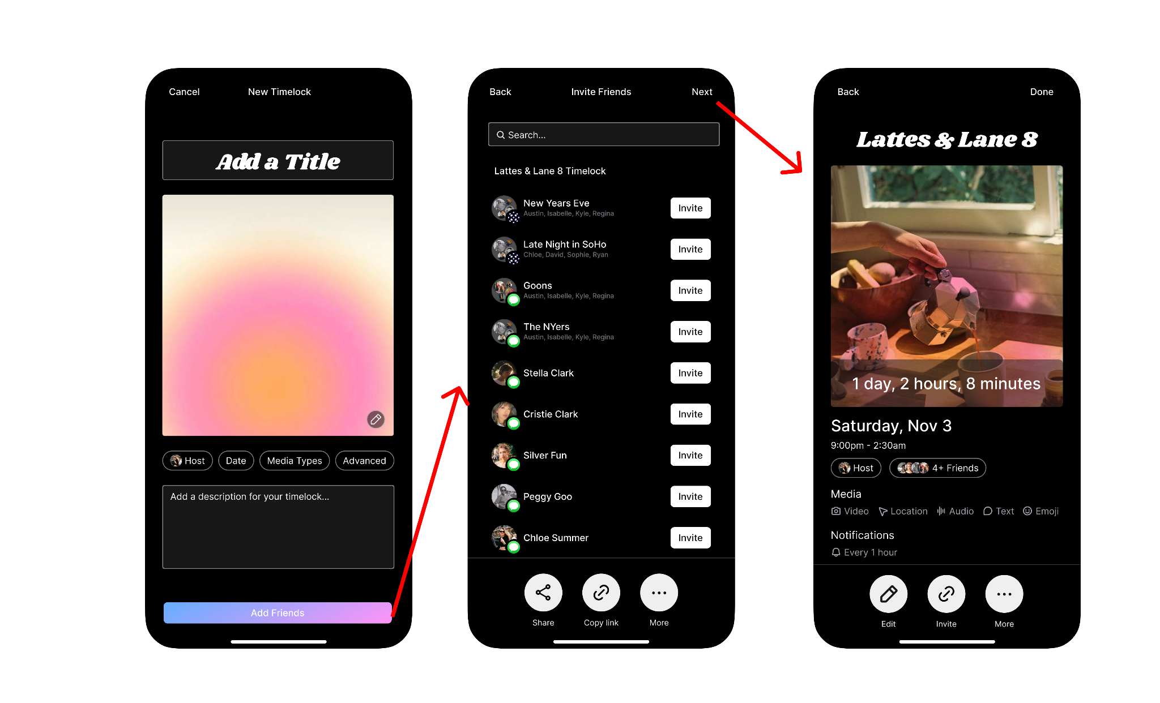
Figure 11: A user can create a timelock, add a title, input metadata (e.g. date, media types, advanced settings). Then, invite friends from within the app, or through other sharing tools (i.e. iMessage). Once the user clicks next, they are presented with their timelock event page.

Task #3, Complex: A user shares the final memento.
Some superusers will want to share the timelock media beyond the immediate group in the timelock, e.g., on social media or with other friends and family. This task gives users the ability to share the timelock event outside of timelock participants and promotes platform growth. After considering privacy concerns, we decided that the mechanism for this task will be via a one-time link, so that the timelock cannot be reshared without permission.
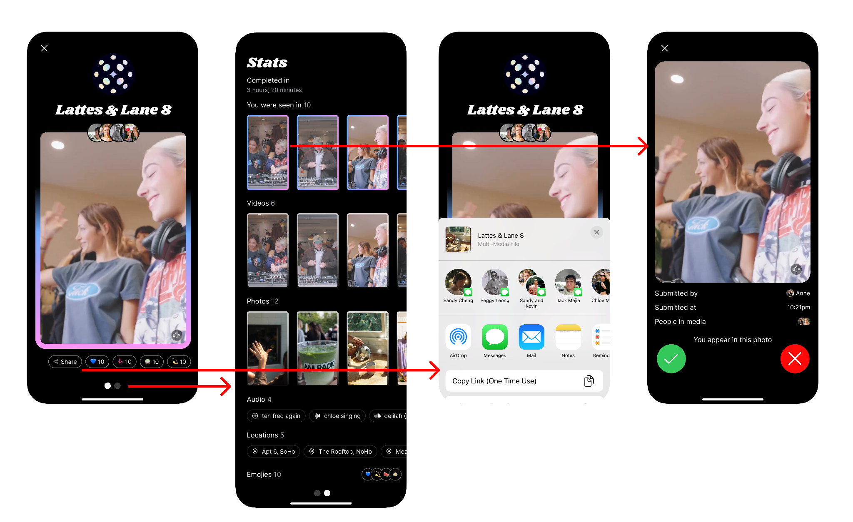

Figure 12: A user can view a timelock, and swipe from left to right to see the timelock stats. The user also has the ability to share a timelock, but the link is only a one time user. Additionally, a user can either accept or reject photos that they appear in, so that certain photos are not in the timelock forever.

Design Evolution

Initial Sketches
The project began with extensive sketching explorations to visualize different approaches to the interface and user experience. We brainstormed a variety of design directions, including mobile apps and iMessage widgets. After analyzing the novelty and feasibility of each sketch, we decided to move forward with the mobile app, since building an iMessage widget was not feasible given the skillset and timeframe constraints on our team.
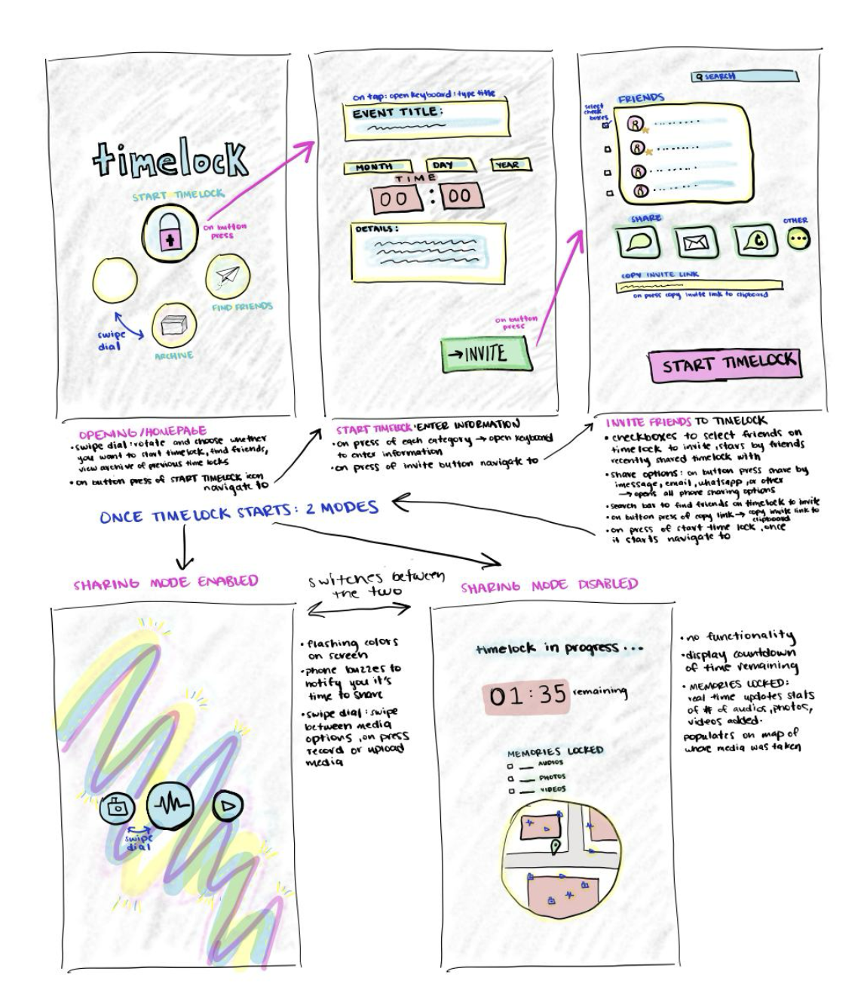
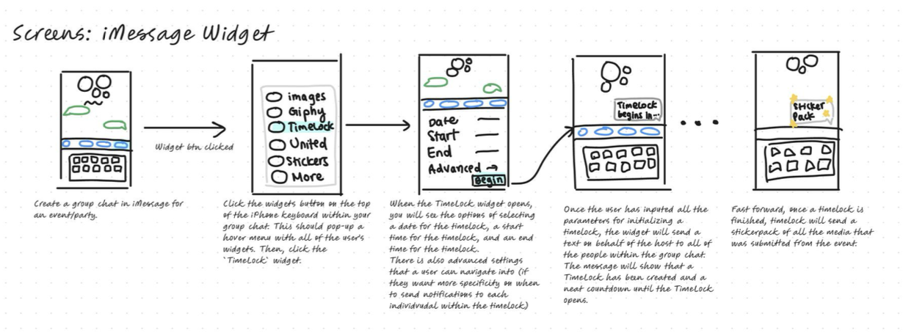Figure 13: Initial sketches of mobile and iMessage widget.

Lo-Fi Prototype and Evaluation
From there, we began sketching our three task flows. First, we sketched our initial low-fi prototype of all three tasks digitally within Figjam.
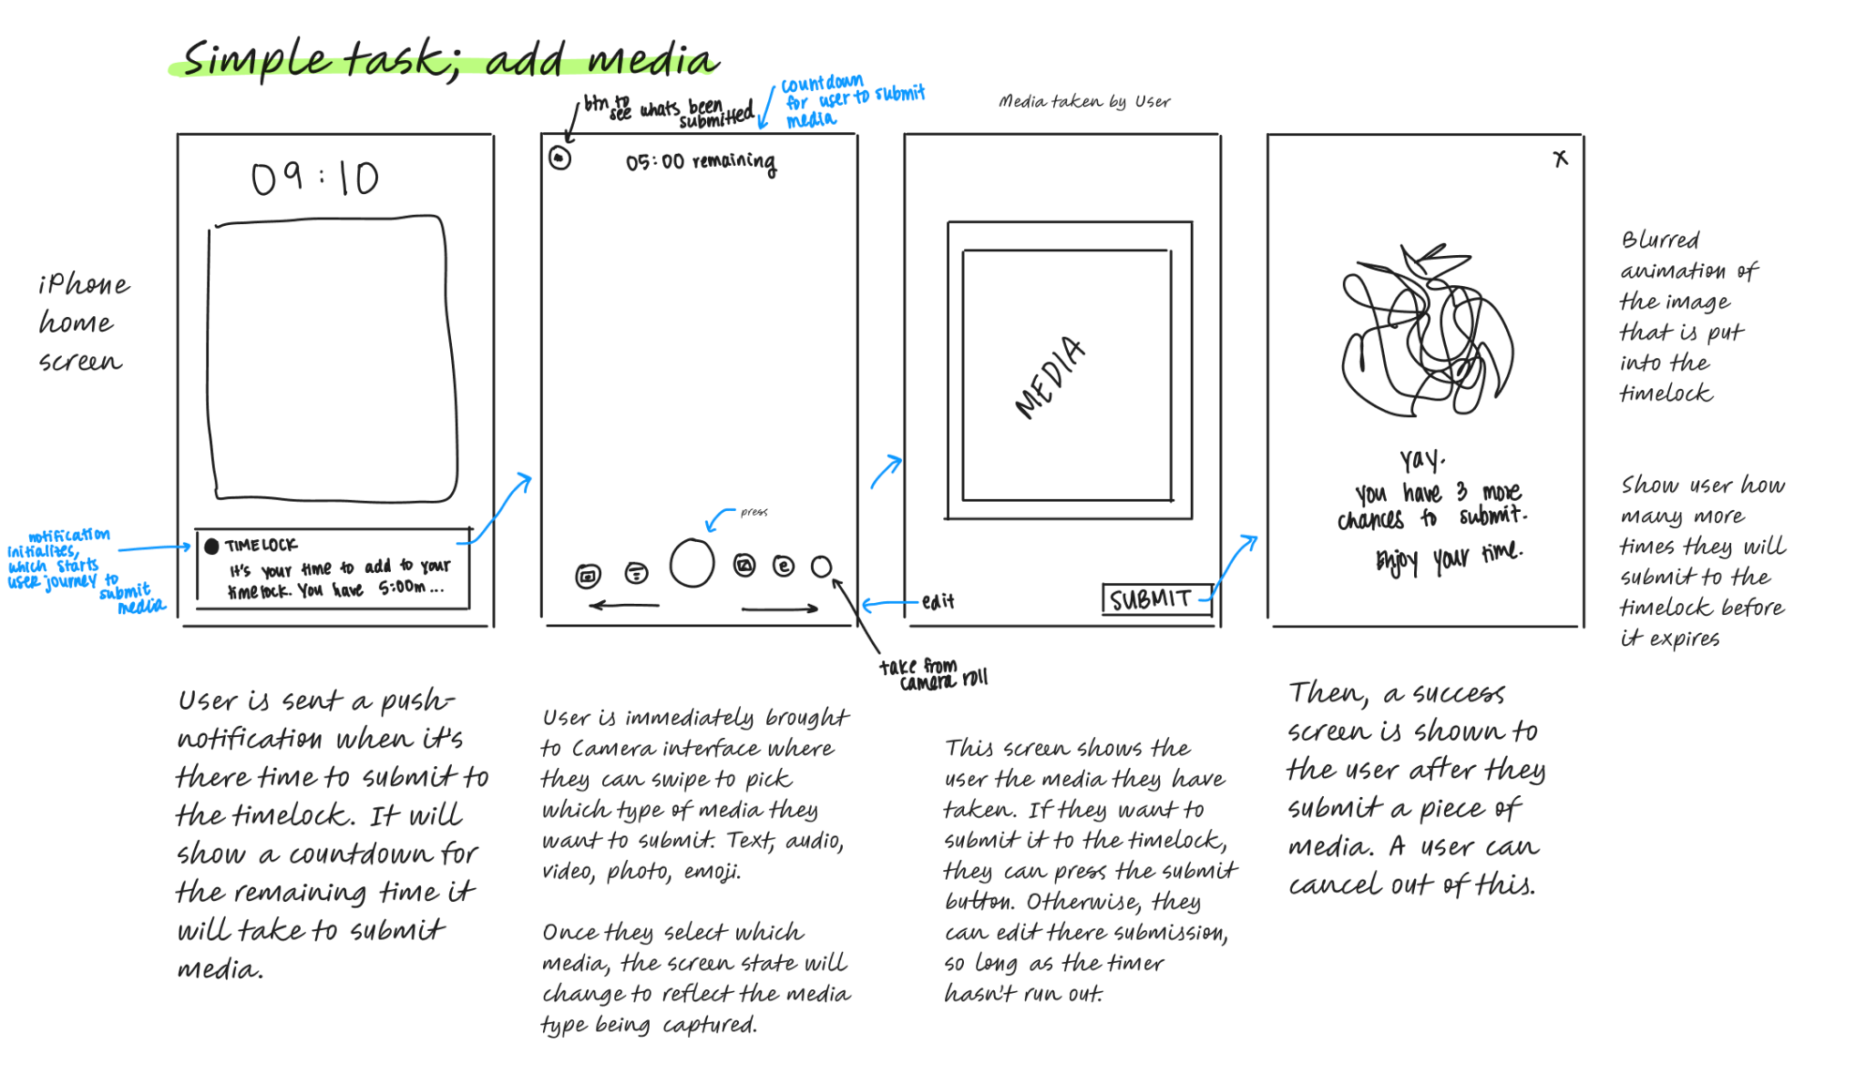
Figure 14: Figjam Lo-Fi Prototype of Simple Task

Figure 15: Figjam Lo-Fi Prototype of Simple Task
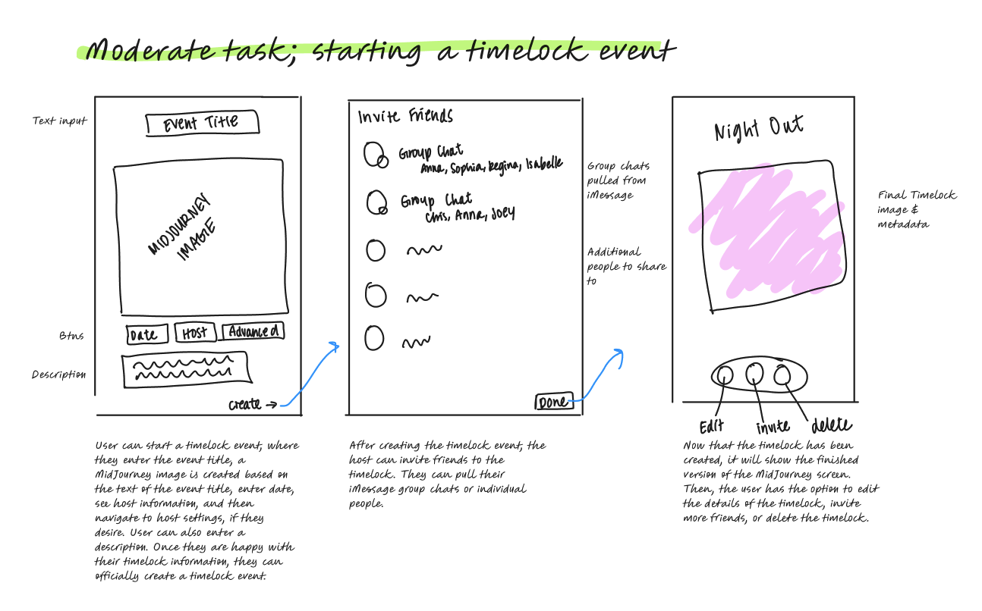
Figure 16: Figjam Lo-Fi Prototype of Moderate Task
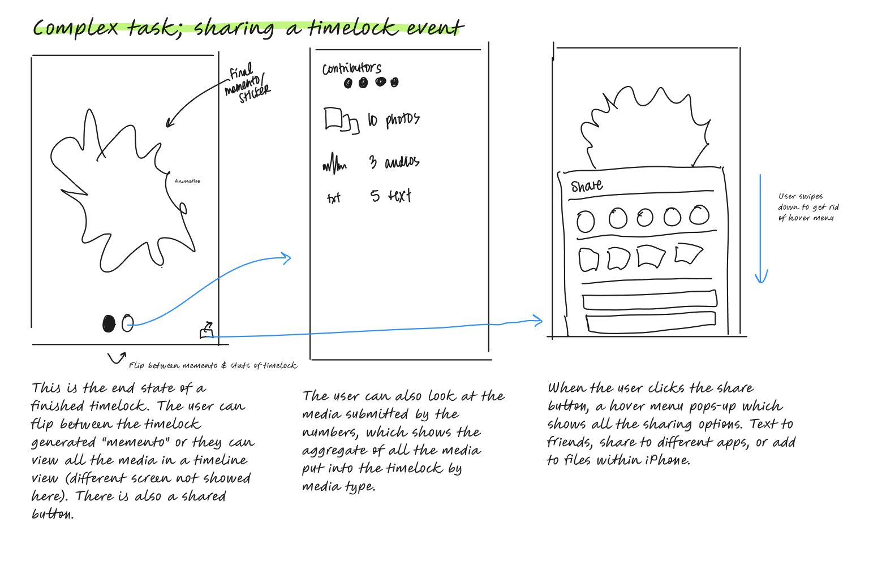
Figure 17: Figjam Lo-Fi Prototype of Complex Task

From there, we created paper prototypes from the Figjam user flows. We wanted to be creative in the way that we tested our paper prototypes since a lot of the task flows involved actions taken by the user where they had to use the camera feature on their phone. For example, in our moderate task flow, we cut out a section of the paper to resemble the idea of someone taking a photo or video, so when the user tested the paper prototype they had a more realistic way of visualizing the camera behavior.
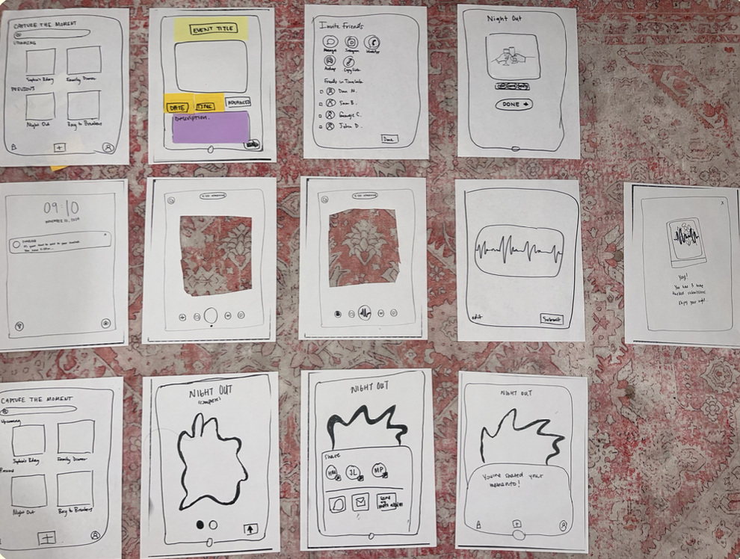
Figure 18: Full Lo-Fi Prototype. To note, in our moderate task flow (second row), our second and third screens are cut out to resemble the idea of a user using the camera feature on their phone.
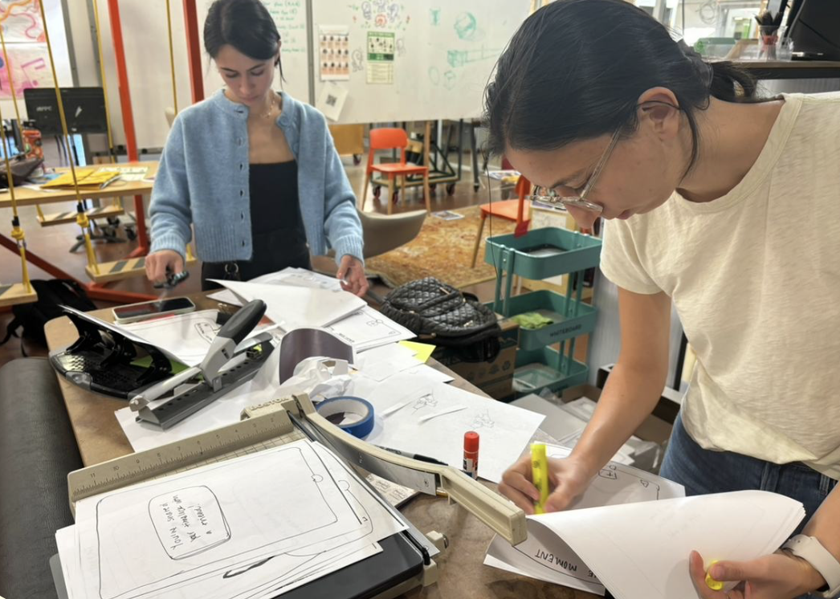
Figure 19: Sophia and Isabelle creating the full lo-fi prototype in the d.school.
User testing was conducted on four participants in our target demographic. Each participant was asked to navigate through each task flow. To evaluate our prototype, we collected both qualitative user feedback through think-aloud protocols and measured key usability metrics including whether users successfully completed tasks, the relative time taken for task completion, and instances where users encountered "dead ends" in the navigation. We also assessed user satisfaction through verbal feedback after testing to understand if users would use the app again or recommend it to friends.
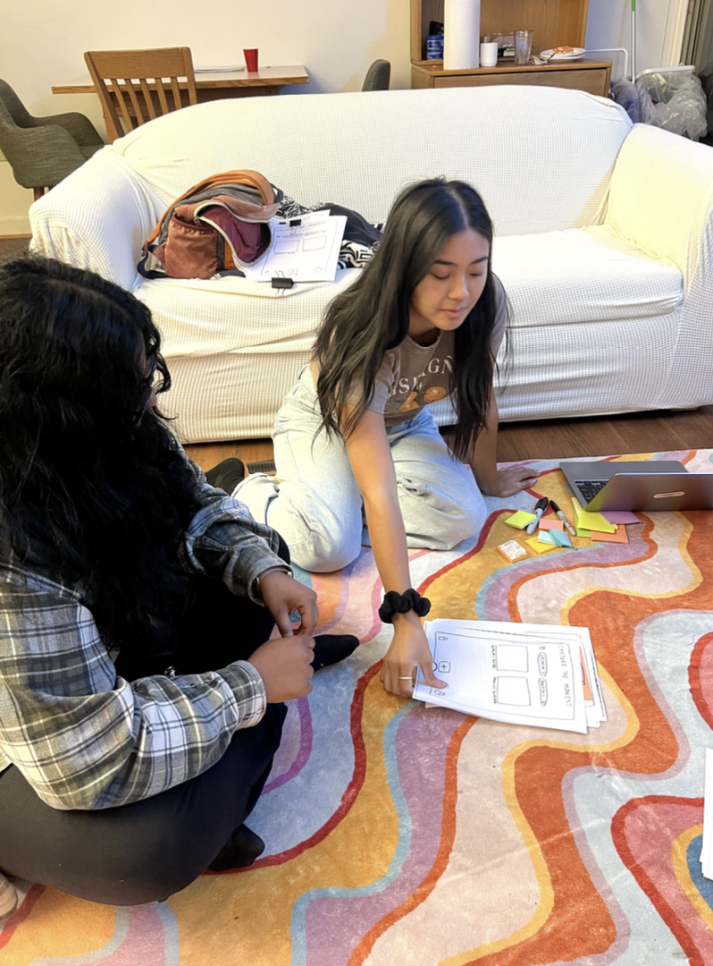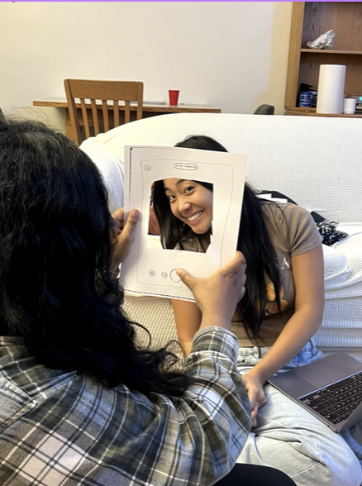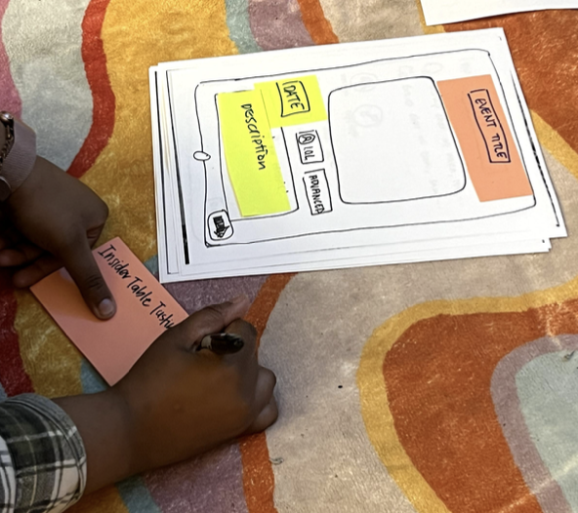
Figure 20: Regina testing our lo-fi prototype with a participant.

During the lo-fi prototype testing, we learned that users wanted the app to feel more social and be able to interact more meaningfully in real-time with other users. To balance real-time interaction on the app with our value of presence, we updated our app to have social features, such as reactions and comments once the event is over or discretely during the 5 minute user submission window. Prototype participants also expressed a desire to add captions to media. which was also added to our next iteration of designs for timelock. We tried our best to iterate on feedback during each round of user testing. We made small adjustments to our paper prototype to help with user navigation.
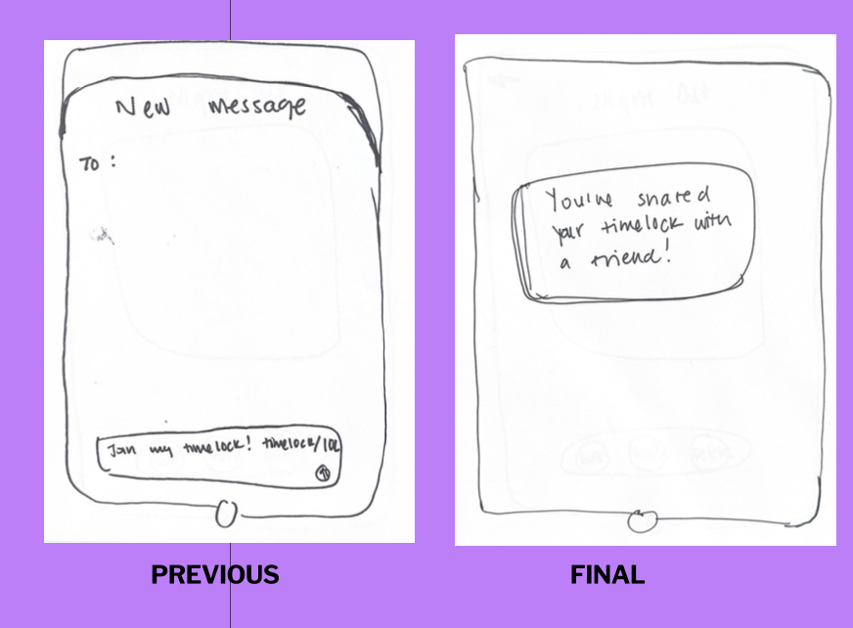
Figure 21: Example of revised paper prototype during participant rounds of testing.

Based on testing, we revised our user interface in the next iteration of task flows, which is discussed in more detail within the next section.

Medium-Fi Prototype and Heuristic Evaluation

During the next iteration of timelock’s design process, we focused heavily on converting our feedback from our paper prototype testing into our medium-fi prototype. Based on what we learned, we revised our interface in several key ways. First, we added social components to the product.
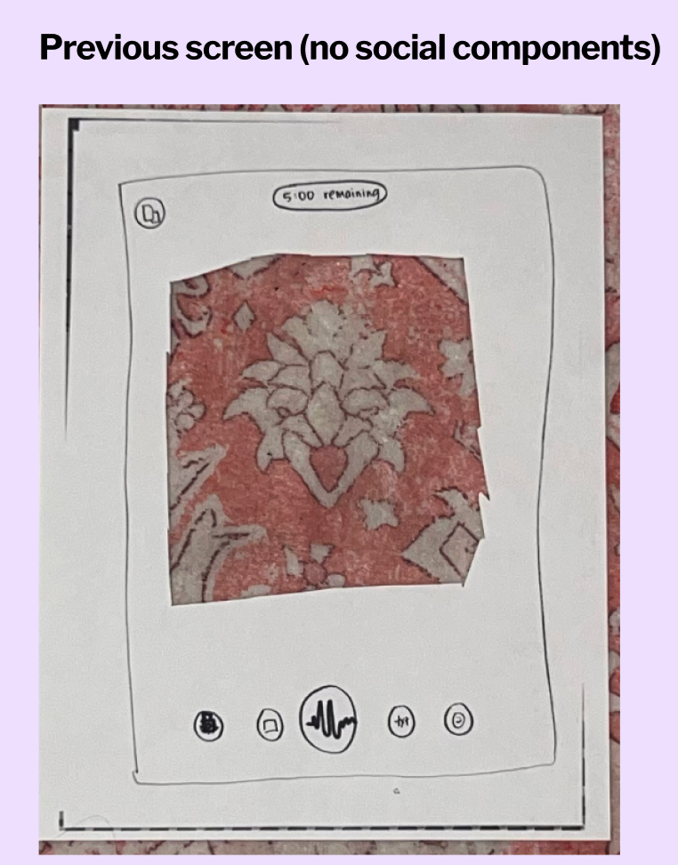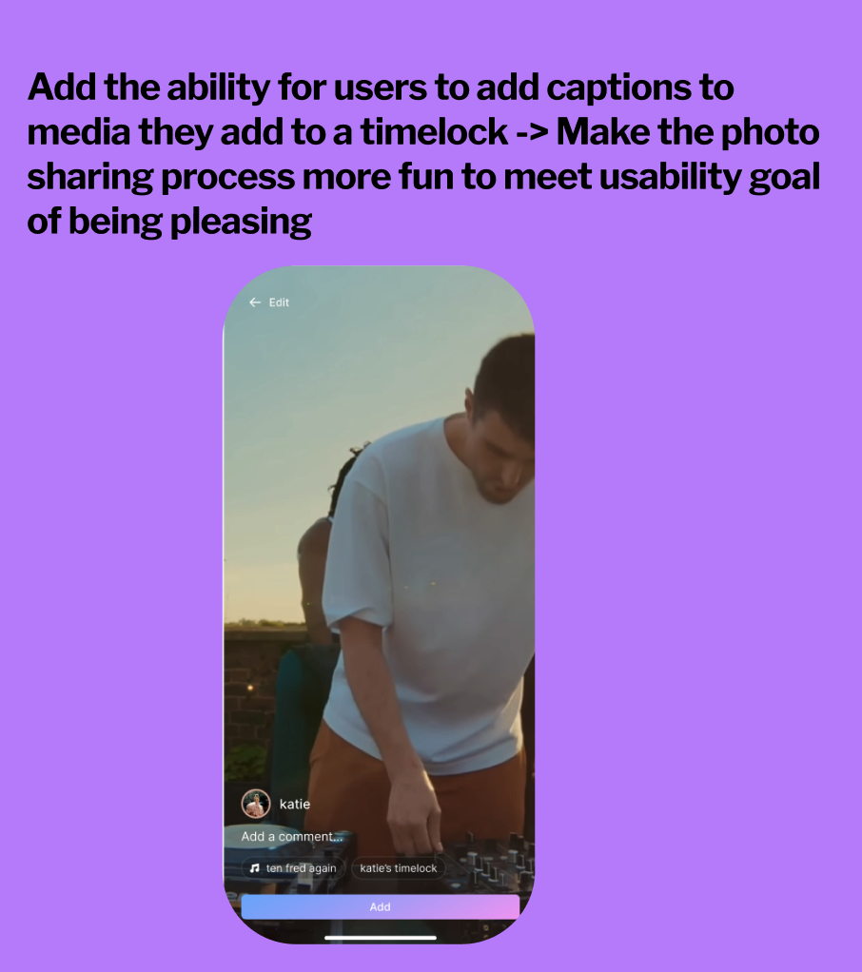
Figure 22: Revised interface based incorporating social components in the moderate task flow.

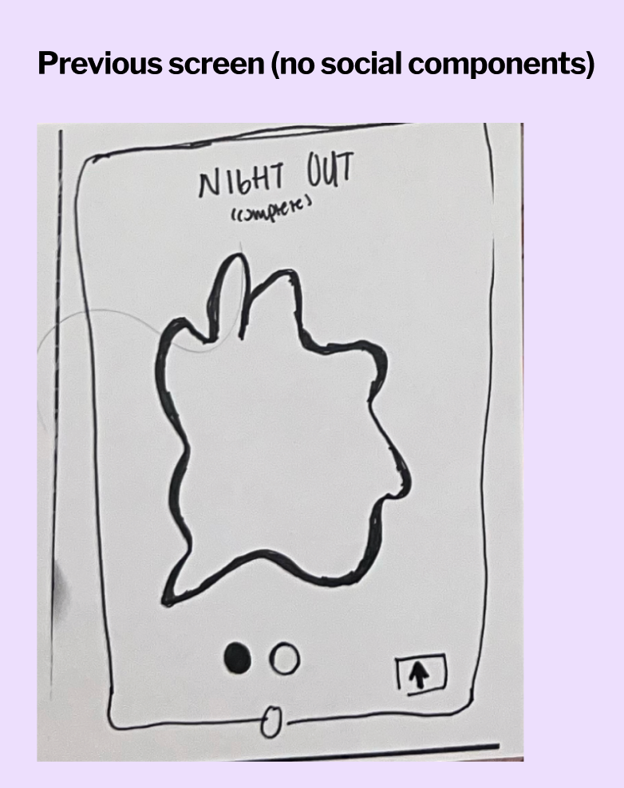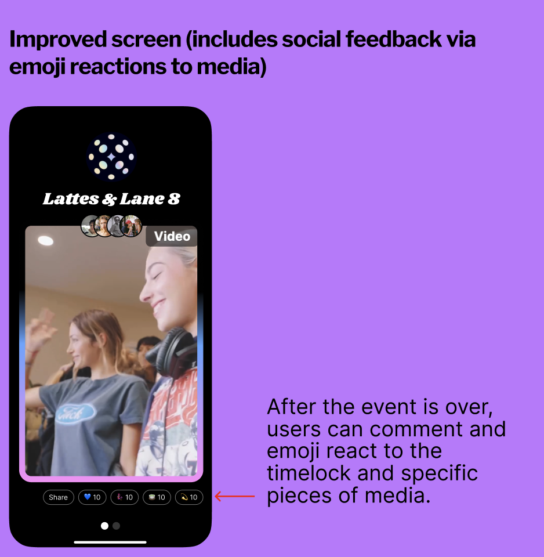
Figure 23: Revised interface based incorporating social components in the complex task flow.

Another significant finding was the importance of fixing dead ends and revising our navigation system to have emergency exits.The team also found that users wanted clear confirmation when their actions were successful, leading to the implementation of more explicit success states in the interface. This was especially important for time-sensitive actions within the application.

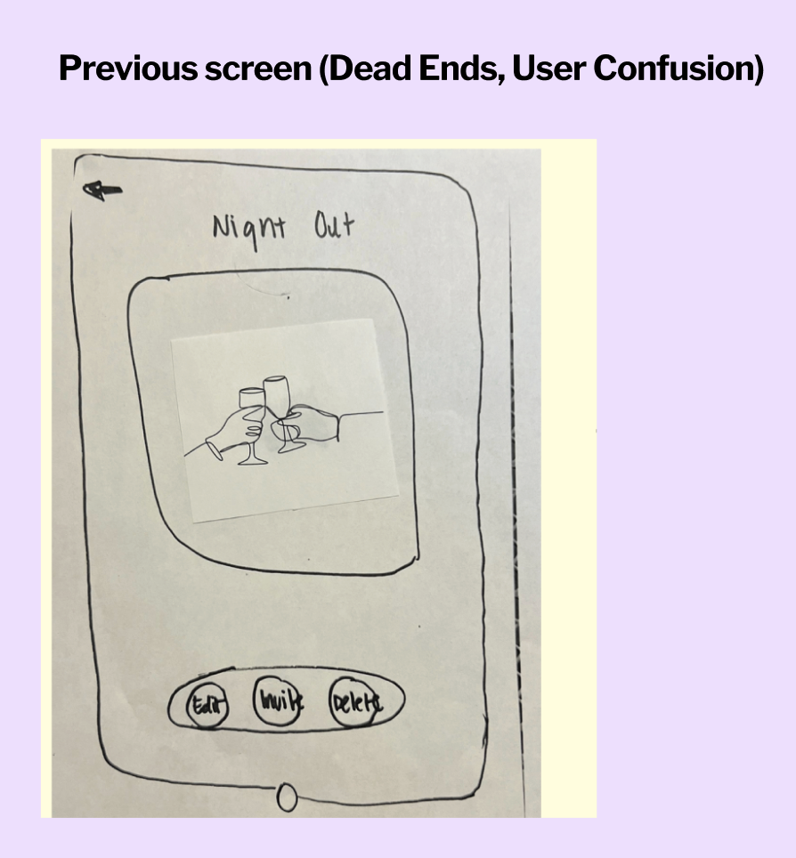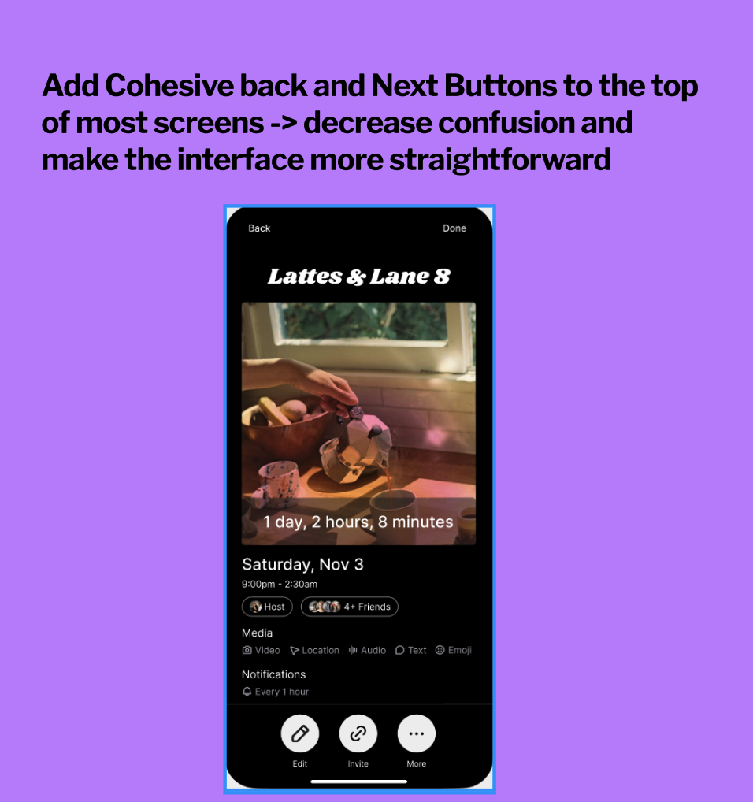
Figure 24: Revised interface fixing dead ends and helping the user navigate.

In our heuristic evaluation, we received seven violations of severity 0, 17 violations of severity 1, 12 violations of severity 2, 7 violations of severity 3, and 6 violations of severity 4. We focused on correcting violations of severity 3 and 4, most of which were issues of H4 (error prevention) and H5 (user control and freedom).

A lot of the feedback centered around connecting different tasks within the app, so that the experience feels more cohesive, and error prevention through UI changes, e.g., adding back buttons or notifying users that submitted media cannot be edited. Both our heuristic evaluators and our section expert also noted privacy concerns within the app, which led to the creation of two new privacy features.

Home Page / H1: Visibility of System Status / Severity 3
- Issue: No transition between “locked” timelock and creating a timelock. App lacks a home screen.
- Rationale: Adding a home screen is important to make the tasks flow together more cohesively.
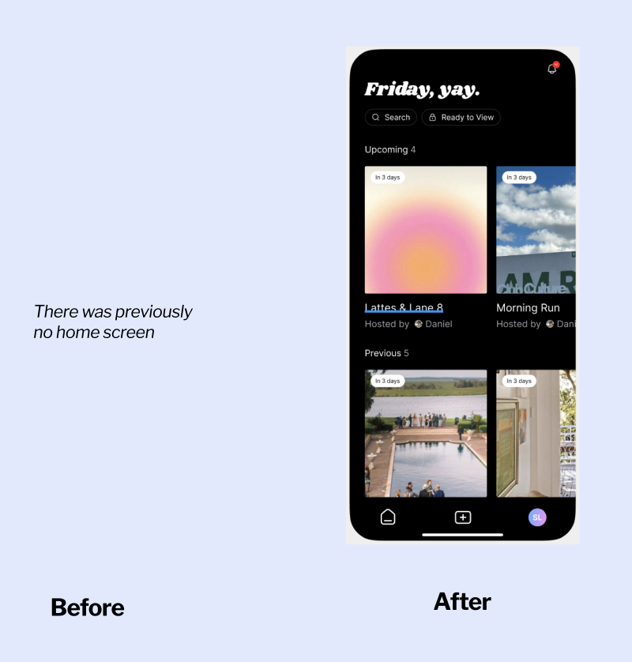

Capturing Media / H5 - Error Prevention / Severity 3
- Issue: Button icon at the bottom of timelock screen is confusing.
- Rationale: The button is meant to indicate which timelock event a user is a part of, but since the user is highly unlikely to be part of several timelocks at once and it was causing confusion, we removed it entirely.
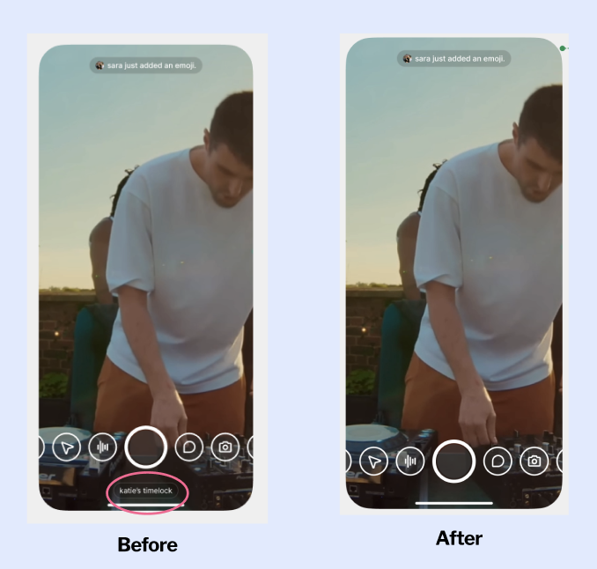

Creating a timelock / H8 - Aesthetic and Minimalist Design
- Issue: On the create a timelock page, it is unclear how to edit and change the graphic.
- Rationale: Added edit button to give user more control and improved copy to better reflect the actions a user needs to take on this page.
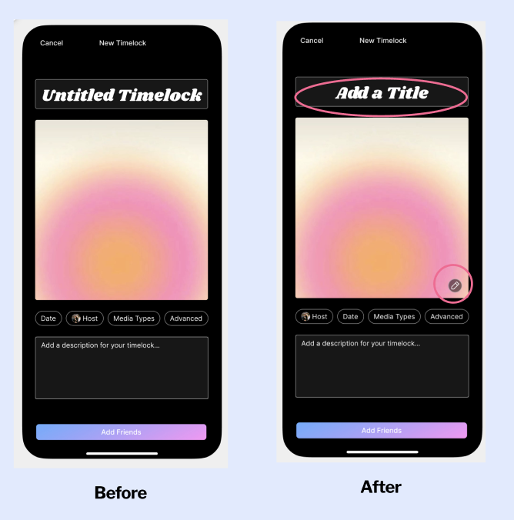

Viewing a timelock / H3 - User Control and Freedom / Severity 4
- Issue: Users do not have an emergency exit once they click the timelock memento and when they submit their individual photos to the timelock.
- Rationale: Added an exit button (x on top right corner) to address this issue so that users can leave this page.
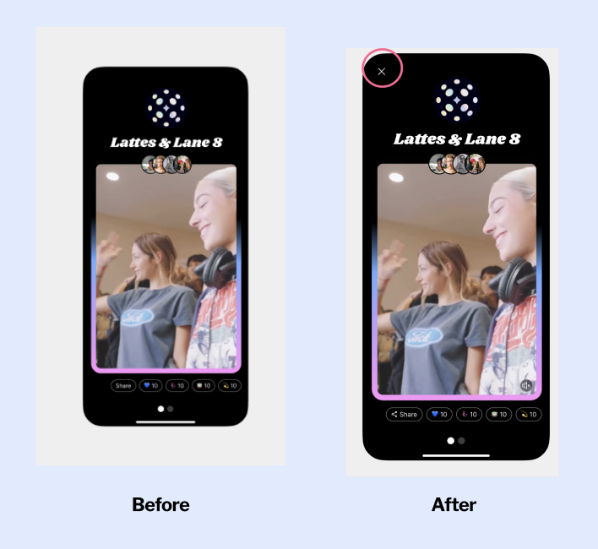
Viewing a timelock / H11 - Accessibility / Severity 3
- Issue: Audio may be stuck in a loop when users view the memento.
- Rationale: Added a mute button so that video and use has more flexibility about how to interact with their media.

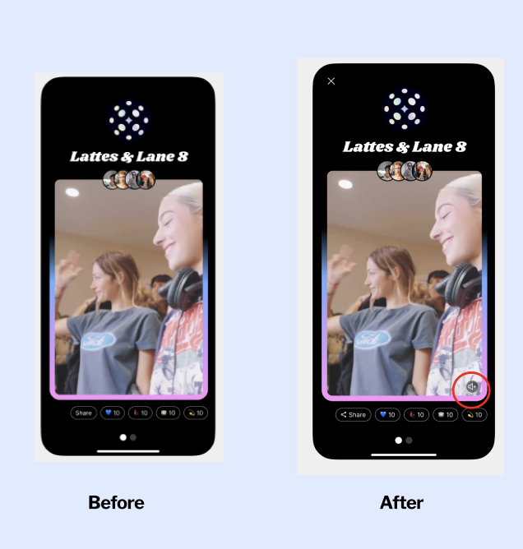

Capturing Media / H5 - Error Prevention / Severity 3
- Issue: Users might be surprised that they are unable to edit their media after submitting.
- Rationale: Locking the media once it is submitted is part of our design principles, but we should give fair warning to the user, so we added a flag/toast to warn the user before they submit.
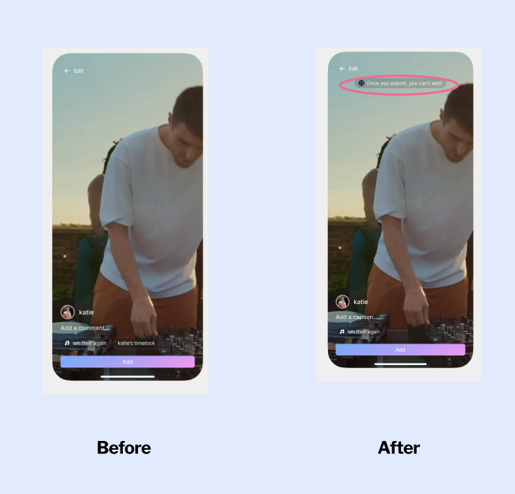
Reporting Images / H2 - Value Alignment & Inclusion / Severity 3
- Issue: Users do not know what will be in the timelock until the memento is released, which can raise issues if there is something uploaded that a user doesn't want to be seen.
- Rationale: Adding a dedicated screen for users to accept/deny images that are in the timelock to enable better privacy controls.
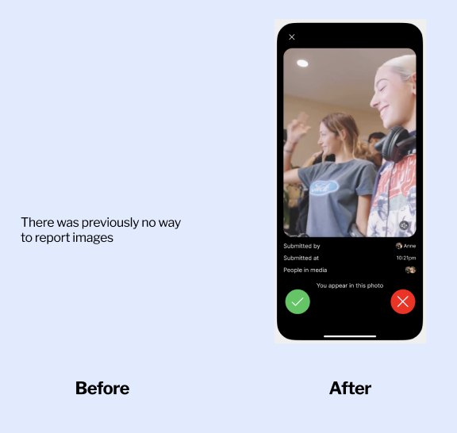
There were also issues found by evaluators that we decided as a team not to address as some would have conflicted with our core product and design values.
H5 / Error Prevention / Severity 4
- Issue: User should be able to select and submit multiple mediums.
- Unaddressed because multiple mediums is an edge case.
H4 / User Control and Freedom / Severity 4
- Issue: User should have the option to add and remove additional tags to their piece of media.
- Unaddressed because tags auto-generated to streamline the process.
H7 / Flexibility & Efficiency of Use / Severity 3
- Issue: Users should be able to submit a piece of media outside of their time slot.
- Unaddressed because one of our core design principles is presence. If a user misses their time slot, they must wait until their next slot to contribute.
H10 / Help & Documentation / Severity 3
- Issue: The interface does not provide guidance on submitting a timelock for a first time user.
- Unaddressed because a full onboarding flow was deemed unnecessary for our first iteration, and current copy within the app helps guide users.

Values
The project is built around three fundamental core values:
Staying Present
The app is designed to support media collection without distracting from real-life experiences of spending quality time with friends. The key principle is to minimize time spent on the app during events. This is supported through features like: 5 minute time limit to submit media, app "locking" when it's not your turn to submit media, and preventing viewing of timelock content until after the event.
Privacy
The application prioritizes user safety and content control. Key privacy features include: timelocks are private by default and cannot be "discovered" within the app, users can share content but maintain control over their data, and users receive notifications when they appear in photos and can blur or remove themselves.
Anticipation
While emphasizing presence during events, the app builds excitement around media contribution and viewing the final collection. Supporting features include: unplanned notifications that randomly select users to contribute, content remains hidden until the event concludes, users receive updates about others' contributions during their turn, and countdown timer to build excitement.

Value Tensions
In addition to our core product values, we encountered several tensions while designing Timelock that required careful balancing and led to important design decisions.
Presence vs Documentation
Our primary tension emerged between wanting users to be fully present at events while still enabling memory capture. We designed a time slot system to minimize constant documentation, but this created stress about potentially missing moments. We addressed this by allowing photo roll uploads if time slots are missed and keeping time slots brief. However, this solution still doesn't fully resolve the fundamental tension between experiencing versus documenting moments.
Privacy vs Social Sharing
A significant tension arose between enabling easy social sharing and protecting user privacy. Users don't know what content will be in the timelock until release, raising concerns about inappropriate or unwanted content. We implemented privacy controls like an image approval screen and one-time use sharing links, but this adds friction to the sharing process. The challenge remains of balancing seamless sharing with adequate privacy protections.
User Control vs Simplicity
We struggled with balancing comprehensive user control against maintaining a simple interface. Features like multiple media uploads and custom tagging would provide more control but complicate the experience. We chose to prioritize simplicity with single media uploads and automated tagging, while providing essential controls like the ability to approve/deny content. This means some users might find the app too basic for their needs.
Real-time Engagement vs Flexibility
The tension between encouraging real-time participation and providing flexibility manifested in our time slot system. While we want users to capture moments as they happen, strict time windows might cause stress or missed opportunities. Our compromise of allowing photo roll uploads helps but potentially undermines the spontaneous, in-the-moment nature we aimed to create.
Individual Expression vs Group Cohesion
By creating a collaborative memory capture system, we faced tension between individual creative expression and maintaining a cohesive group experience. While users can contribute their own media, the format and timing are standardized. This might limit personal expression but helps create a more unified final memento.

Final Prototype Implementation

Tools Used
For the development of the Timelock app, our team utilized a robust combination of React Native and Expo as the primary development frameworks. This selection enabled rapid development and seamless integration of various functionalities essential for the app. The app's navigation system was built using React Navigation's Stack Navigator, facilitating smooth transitions between different screens and maintaining a coherent user flow. To achieve the app's distinctive visual elements and aesthetics, we employed Expo Linear Gradient for creating subtle gradient effects and Expo Font for implementing custom typography, ensuring a unique and consistent text presentation across the app. React Native Gesture Handler was integrated to enable intuitive swipe interactions, enhancing the app's interactivity and responsiveness. Additionally, we incorporated @expo/vector-icons (MaterialCommunityIcons) for intuitive and visually appealing iconography.

App Architecture and Navigation
The app’s architecture is structured around React Navigation's Stack Navigator, enabling smooth screen transitions, customized headers, and modal presentations. Screens are organized into hierarchical structures to facilitate easy navigation. Custom back and next buttons were added to improve navigation flow. Consistent styling was applied across all navigation components. The entire application is wrapped in GestureHandlerRootView to enable gesture handling using React Native Gesture Handler.

We implemented persistent navigation state management to maintain users' positions across different app sections. Additionally, timeline navigation with horizontal gestures was enabled using React Native Gesture Handler, allowing users to swipe through chronological media.

User Interface Components
The user interface was built using React Native's core components, including SafeAreaView to ensure content remains within safe device boundaries, ScrollView for scrollable content areas, and TouchableOpacity for interactive touch elements. Visual enhancements were achieved with Expo Linear Gradient for background gradients, Expo Font for custom fonts, and MaterialCommunityIcons for a diverse range of intuitive icons, contributing to a cohesive and user-friendly UI.

Media Upload Component
The Upload Media component was developed using React Native Reanimated to create fluid animations and smooth transitions, utilizing useAnimatedStyle and withSpring for responsive gesture handling. Media capture functionalities were implemented with Expo Camera for photos and videos, Expo AV for audio recording, and Expo MediaLibrary for saving and managing media files. A sophisticated menu system was created with ScrollView and snap points to navigate between different media capture modes, including photo, video, audio, location, and text. Specialized interfaces included an audio recording view with a visual waveform, an interactive map for location sharing using React Native Maps, and a text input interface enhanced with KeyboardAvoidingView for smooth text interactions.

Post-capture, the app provides preview and confirmation screens developed using Expo Blur to add depth effects and KeyboardAvoidingView to manage text input without obstructing the UI. Expo Font was used to maintain consistent typography across these screens.

Hard-Coded Data and Limitations
The current implementation of Timelock relies on mock data structures to demonstrate its functionality. Upcoming and previous timelock events are stored in a static constant and images throughout the app are imported from an assets folder. For existing timelock events, navigation parameters, including dates, times, and countdown texts, are also hard-coded into the application. For the purpose of displaying a created timelock, the media galleries and certain social features such as reaction counts and friend lists are also static. With more time, we want our app to ideally handle real-time updates, data persistence, and social features like reactions and friend interactions, but due to the scope and time limitations of this project they remain simulated.

Wizard of Oz Techniques
To demonstrate the intended functionality of Timelock without implementing full backend systems, several features were simulated using Wizard of Oz techniques. The timer system, which is central to the app's concept, uses pre-set values for countdown displays rather than actual countdown calculations for individual users. Similarly, the time-based unlocking mechanism is simulated through navigation rather than real-time verification. Social interactions are simulated through static data, including friend lists, participant counts, and a reaction system with fixed numbers and predefined emoji responses. Media management features for past timelock events, including photo and video galleries, are simulated using static image arrays, while the media upload process demonstrates the intended flow. Location tagging and audio elements are represented through UI elements without backend functionality. Similarly, sharing features are implemented to show the UI flow but friend invitations and collaborative features are simulated through static interfaces. This approach allowed for rapid prototyping and testing of core concepts while focusing on validating the user experience rather than building complete backend systems.

Reflection & Next Steps
We had a few key learnings from the quarter across design thinking, our studio theme, and our own project.

Key Learnings About the Design Thinking Process
Design thinking emphasizes the importance of identifying and balancing tensions throughout the design process, as these often yield the most valuable insights. In unpacking interviews using empathy maps, we analyzed what participants said, did, thought, and felt, paying close attention to contradictions, tensions, and surprises. For example, we discovered that while students desired seamless and effortless photo-sharing experiences, they were still willing to invest time and effort in creating both physical and digital artifacts. These tensions extended beyond interviews into other prototyping stages, where they continued to inform our decisions. After testing a paper prototype, users expressed a desire for more in-app social elements, which initially conflicted with our values of fostering presence at events rather than through the app. Ultimately, we incorporated this feedback sparingly to align with our values while addressing user needs. Revisiting such trade-offs in future iterations will remain essential. Furthermore, user feedback and engagement proved critical at every stage of the process. While user-centered design begins with empathy during the defining stage through interviews, it extends throughout the design lifecycle. CS147 introduced us to tools like POV statements and paper prototyping, which were instrumental in gathering and synthesizing user feedback as we iterated. POV statements allowed us to create grounded user archetypes tied to specific needs, while paper prototyping enabled rapid iteration and real-time user testing, ensuring our designs stayed aligned with user expectations.

Key Learnings About Studio Theme
Through our exploration of the "movement" theme this quarter, we discovered fascinating insights about how people move and share media in digital spaces. While we initially approached movement broadly - examining how users collect, share, and aggregate media online - our research revealed a deeper tension between physical and digital movement at social events. We learned that people struggle with being physically present in a moment while simultaneously trying to document it for future memories. This led us to reframe movement not just as the technical flow of media between users, but as the delicate balance between capturing memories and staying engaged in real-world experiences. Our final solution, Timelock, embraces this duality by facilitating the movement of multimedia memories (photos, videos, audio, locations) while minimizing disruption to users' lived experiences. The project ultimately taught us that meaningful digital movement should enhance rather than detract from physical presence, leading us to design features that encourage collaborative documentation while keeping users focused on the moments that matter.

Key Learnings About Timelock
Using curiosity as our compass proved invaluable throughout our project journey. As a team, we prioritized working on initiatives that genuinely sparked our interest and excitement. This approach was particularly helpful when navigating uncertain territory and making complex design decisions. After conducting our initial round of interviews with one event host and two event attendees, we found ourselves at a crossroads, needing to refine our focus. The conversation with the event host particularly captivated our interest, which led us to pivot our research toward more extreme users in the event space. This decision opened new doors, leading us to engage with festival organizers and a deeply passionate festival attendee. Through these interactions, we uncovered fresh insights about event attendees that we might have missed had we not followed our natural curiosity.

Next Steps
Looking ahead, there are several exciting directions to expand Timelock's capabilities. First, we would enhance the social components of the app based on our user testing feedback, implementing features like live notifications when friends contribute media and enabling comments on shared memories. We'd also explore developing the platform beyond just mobile apps to ensure cross-platform accessibility, potentially including web interfaces and integration with existing social platforms. Additionally, we'd invest in more sophisticated personalization features, using AI to help curate meaningful moments and create more dynamic, interactive mementos that evolve over time. Another crucial area for development would be expanding our privacy controls and consent mechanisms, ensuring users feel secure while sharing their memories. Finally, we'd explore partnerships with venues and event organizers to create specialized Timelock experiences for concerts, festivals, and other large gatherings.
Just as a time capsule preserves precious memories for future discovery, Timelock aims to transform how we capture and cherish our shared experiences, allowing us to be fully present in life's beautiful moments while knowing they'll be thoughtfully preserved for tomorrow.

